

R&D Cell

Department of Artificial Intelligence & Machine Learning
(For Office use only)
Application No.:

DATE:
- IP support service required (Tick the appropriate service)
- Patent: ✔
- Trademark :
- Copyright :
- Design:

- Point of contact (PoC)
- 1st Point Of Contact
Name : Bhavithran.B
Mobile No. for contact:7806852245
WhatsApp No.: 7806852245
Email: rajbharathcse@mvit.edu.in

- 2nd Point Of Contact
Name : Muhammed Abdul Musthaqeem
Mobile No. for contact:8870933502
WhatsApp No.:8870933502
Email:musthaqeem2004@gmail.com

PATENT PARTICULARS

Name of the Applicant:

Inventors:
S.No | Inventor Particulars | Signature (Please Attach the JPEG of your signature)
1 | Name: S.lavanya  Designation: Assistant Professor  Department: AI&ML  Name of the College: Manakula Vinayagar Institue of Technology  Email: la.suga52@gmail.com  Mobile No.9500637537  Whatsapp No.9500637537 | 
2 | Name: Bhavithran.B  Designation: Student  Department: AI&ML  Name of the College: Manakula Vinayagar Institue of  Technology  Email: bhavithran03@gmail.com  Mobile No. 7806852245  Whatsapp No. 7806852245 | 
3 | Name: Aniruth R  Designation: Student  Department: AI&ML  Name of the College: Manakula Vinayagar Institue of  Technology  Email: 052004.aniruthravi@gmail.com  Mobile No. 8870059719  Whatsapp No. 8870059719 | 
4 | Name: Kampa Yaswanth Reddy  Designation: Student  Department: AI&ML  Name of the College: Manakula Vinayagar Institue of  Technology  Email: redddy121204@gmail.com  Mobile No. 7207424365  Whatsapp No.7207424365 | 
5 | Name: Muhammed Abdul Musthaqeem  Designation: Student  Department:AI&ML  Name of the College: Manakula Vinayagar Institue of  Technology  Email: musthaqeem2004@gmail.com  Mobile No. 8870933502  Whatsapp No. 8870933502 | 

A. INVENTION TITLE AND SHORT DESCRIPTION: Please provide the title and also a short description about the invention. (What’s the invention about?)
Smart Street Light Monitoring System . This innovative solution aims to efficiently manage and optimize street lighting infrastructure using IoT (Internet of Things)
B. PROBLEM: What overall problem(s) does the proposed invention solve or what purpose does it serve? (Note: Please be specific, spell out acronyms and provide enough layman level detail to fully explain the problem.)
the problems overcome by the Smart Street Light Monitoring System in a concise manner:
- Energy Consumption: LED-based lamps reduce energy usage compared to traditional lamps.
- Maintenance Challenges: Integrated monitoring helps identify faulty components promptly.
- Unmetered Load Billing: Smart sensors improve accuracy in energy consumption billing.
- Photo-Sensor Reliability: Regular maintenance ensures reliable operation.
- Fragmented Solutions: Integrated systems enhance overall efficiency.
C. EXISTING SOLUTIONS / PRIOR ART/RELATED APPLICATIONS & PATENTS:
Smart street light monitoring systems using IoT (Internet of Things) are a growing technology with many existing solutions, prior art, and related applications and patents. Here's a breakdown of the key areas:
Existing Solutions
- Light-based control: Photocells or light-dependent resistors (LDRs) are used to automatically turn on street lights at dusk and off at dawn. This is a basic level of automation that has been around for many years.
- Time-based control: Timers are used to turn on and off street lights at predetermined times. This can be less efficient than light-based control, as it doesn't take into account actual light levels.
- Centrally managed systems: Some cities are deploying systems that allow for central management of street lights. These systems may use a variety of sensors and communication technologies to monitor and control light levels.
Prior Art
There are many patents and other forms of prior art related to smart street light monitoring systems. Some of the key areas of prior art include:
- US Patent 4,727,342: This patent, issued in 1988, describes a system for controlling street lights based on traffic flow.
- US Patent 6,441,774: This patent, issued in 2002, describes a system for controlling street lights based on ambient light levels and motion detection.
Related Applications
Smart street light monitoring systems have a variety of potential applications, including:
- Energy savings: By automatically adjusting light levels based on actual needs, smart systems can save a significant amount of energy.
- Improved public safety: Better lighting can help to deter crime and improve pedestrian safety.
- Reduced maintenance costs: By remotely monitoring the health of street lights, cities can identify and fix problems before they become major issues.
- Environmental benefits: Reduced energy consumption can help to reduce greenhouse gas emissions.
Patents
There are a number of patents related to smart street light monitoring systems. Some of the most recent patents include:
- US Patent 9,476,406: This patent, issued in 2016, describes a system for controlling street lights using a mesh network.
- US Patent 10,033,427: This patent, issued in 2018, describes a system for controlling street lights using a blockchain.
The development of smart street light monitoring systems is a rapidly evolving field. New technologies and applications are emerging all the time. As these systems become more sophisticated, they have the potential to significantly improve the efficiency, safety, and sustainability of our cities.

D. DESCRIPTION OF PROPOSED INVENTION:
This invention builds upon existing smart street light systems by incorporating additional sensors, improved functionalities, and a robust IoT network for enhanced efficiency, safety, and data collection.
System Components:
- Smart Street Light Fixtures: These fixtures will house:
  - LED Lights: Energy-efficient LED lights with dimming capabilities.
  - Microcontroller Unit (MCU): The brain of the system, responsible for processing sensor data and controlling light functions.
  - Light Sensor: Measures ambient light levels for automatic dusk-to-dawn adjustments.
  - Passive Infrared (PIR) Sensor: Detects motion to activate lights when pedestrians or vehicles are present.(Optional: Additional sensors like radar or ultrasonic for improved detection in all weather conditions)
  - Camera (Optional): Provides visual data for security purposes, incident detection, and traffic analysis.
  - Communication Module: Enables connection to the IoT network (e.g., cellular, LoRaWAN).
  - Power Supply: Can be a combination of grid power and a small solar panel with battery backup for increased sustainability.
System Functionality:
- Automatic Light Control: Based on light sensor data, the system automatically adjusts light intensity throughout the night. PIR sensors ensure lights activate when motion is detected, further optimizing energy used.
- Remote Monitoring and Control: A central management platform allows real-time monitoring of individual light status, energy consumption, and sensor data. Users can remotely adjust light levels, set schedules, and identify potential issues.
- Data Collection and Analysis: The system collects valuable data on traffic patterns, pedestrian activity, and even weather conditions (if additional sensors are used). This data can be used for informed decision-making on infrastructure improvements, traffic management, and resource allocation.
- Predictive Maintenance: By analyzing sensor data, the system can predict potential problems like lamp malfunctions or power outages. This allows for proactive maintenance, reducing downtime and repair cost
- Smart Integration (Optional): The system can integrate with other smart city initiatives, such as traffic management systems or emergency response networks.
Benefits:
- Significant Energy Savings: Automatic dimming and motion-based activation drastically reduce energy consumption compared to traditional street lights.
- Enhanced Public Safety: Improved lighting deters crime and increases pedestrian safety, especially in low-traffic area
- Reduced Maintenance Costs: Predictive maintenance based on sensor data minimizes downtime and repair needs.
- Data-Driven Decision Making: Valuable data collection allows for informed planning and resource allocation in city management.
- Scalability and Adaptability: The system can be easily scaled to accommodate growing cities and adapt to new technologies and functionalities.

E. NOVELTY and KEY FEATURES: Please provide a one-sentence description of what distinguishes your idea from the prior art. This is a statement of what is new, and not a business case.
- The key novelty of this proposed smart street light system lies in its combination of multi-sensor data analysis (light, motion, optional visual) with a central IoT platform for real-time control, predictive maintenance, and smart city integration. This goes beyond basic light control to offer a holistic approach to intelligent urban lighting management.
F. COMPARISON: Please provide advantages and basic differences of the proposed solution over previous solutions.

Proposed Solution vs. Previous Smart Street Light Systems using IoT
Here's a breakdown of the advantages and key differences between the proposed solution and existing smart street light systems:
Feature | Existing Solutions | Proposed Solution
Sensors | Mostly light sensors for dusk-to-dawn control. | Light sensors, PIR sensors (optional camera) for adaptive control.
Light Control | Basic on/off or dimming based on light levels. | Adaptive dimming based on light levels, motion detection, and potential weather conditions (with additional sensors).
Data Collection | Limited or no data collection beyond light levels. | Real-time data collection on light status, energy use, sensor readings (motion, camera footage if applicable).
Maintenance | Relies on reactive maintenance after failure. | Predictive maintenance based on sensor data analysis.
Integration | Limited or no integration with other smart city systems. | Potential for integration with traffic management, emergency response networks, etc.
Focus | Primarily on energy savings through basic automation. | Holistic approach for energy savings, public safety, data-driven decision making, and smart city integration.

Advantages of Proposed Solution:
- More Efficient Light Control: Utilizes multiple sensors for a more nuanced approach to light control, potentially leading to greater energy savings.
- Enhanced Public Safety: Motion detection ensures lights activate for pedestrians and vehicles, improving safety in low-traffic areas. (Optional camera can provide additional security benefits)
- Predictive Maintenance: Reduces downtime and repair costs by anticipating potential issues based on sensor data.
- Data-Driven Insights: Valuable data collection allows for informed decision making on infrastructure, traffic management, and resource allocation.
- Smarter City Integration: Potential to connect with other smart city initiatives for a more comprehensive urban management system.
Overall, the proposed solution offers a more sophisticated and data-driven approach to smart street light monitoring, providing significant benefits beyond basic energy savings.

G. CLAIMS:
- A smart street light fixture, characterized by:
  - A combination of light sensors, passive infrared (PIR) sensors, and optionally a camera, for gathering comprehensive environmental data.
  - A central processing unit that utilizes this multi-sensor data to adaptively control light intensity and activation based on real-time conditions.
  - An integrated communication module enabling connection to an IoT network for remote monitoring and control.
- A method for intelligent street light management using IoT, comprising:
  - Real-time data collection on light status, energy consumption, and sensor readings (motion, visuals from the camera if equipped).
  - Utilizing this data for adaptive light control, optimizing energy use while ensuring proper illumination based on ambient light and motion detection.
  - Facilitating predictive maintenance by analyzing sensor data to anticipate potential problems and prevent outages.
  - Enabling data-driven decision making for urban planning through insights into traffic patterns, pedestrian activity, and environmental conditions (with additional sensors).
  - Offering the potential for seamless integration with other smart city systems for a more comprehensive urban infrastructure management approach.
- A smart street light monitoring system substantially as described in claim 1 or 2, wherein the system offers a holistic approach to intelligent lighting management that goes beyond basic automation.

H. ADDITIONAL INFORMATION: Please provide additional information such as, a claim set, drawings, a software code, etc.).
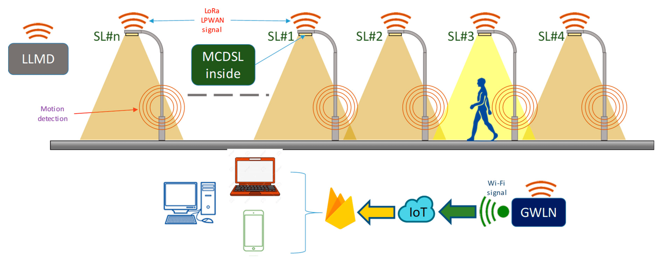

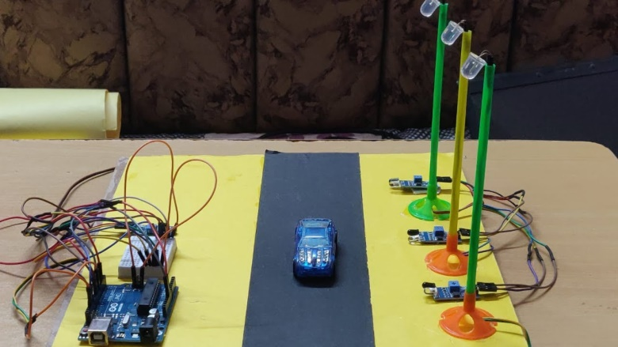

I.OBJECTIVE OF THE INVENTION
The main objective of a smart street light monitoring system using IoT (Internet of Things) is to create a more efficient and intelligent lighting infrastructure for cities. This can be achieved through several key goals:
- Energy Efficiency: By using sensors to detect ambient light levels and movement, the system can automatically adjust the brightness of streetlights. This reduces energy consumption significantly compared to traditional on/off schedules.
- Cost Reduction: Lower energy use translates to cost savings on electricity bills for municipalities. Additionally, remote monitoring can help identify and address faults promptly, minimizing maintenance needs.
- Improved Public Safety: Better lighting control can enhance visibility in areas with low traffic or during nighttime hours, potentially deterring crime and improving pedestrian safety.
- Environmental Sustainability: Reduced energy consumption leads to a smaller carbon footprint, contributing to a more sustainable urban environment.
- Data-Driven Management: The system can collect valuable data on energy usage, traffic patterns, and potential outages. This data can be used to optimize lighting strategies and improve overall city management.

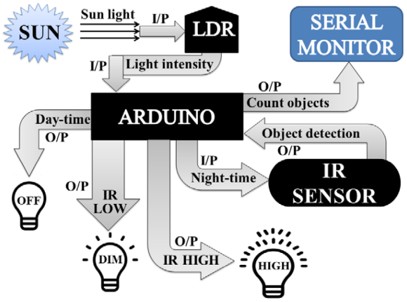
J. DRAWINGS

